* **What is Linux Operating System?**

Linux is a community of open-source Unix like operating systems that are based on the [Linux Kernel](https://www.geeksforgeeks.org/the-linux-kernel/). It was initially released by **Linus Torvalds** on September 17, 1991. It is a free and open-source operating system and the source code can be modified and distributed to anyone commercially or noncommercially under the GNU General Public License.   
Initially, Linux was created for personal computers and gradually it was used in other machines like servers, mainframe computers, supercomputers, etc. Nowadays, Linux is also used in embedded systems like routers, automation controls, televisions, digital video recorders, video game consoles, smartwatches, etc. The biggest success of Linux is Android (operating system) it is based on the Linux kernel that is running on smartphones and tablets. Due to android Linux has the largest installed base of all general-purpose operating systems. Linux is generally packaged in a Linux distribution.

* **Components of Linux System**

Linux Operating System has primarily three components:

* **Kernel** − Kernel is the core part of Linux. It is responsible for all major activities of this operating system. It consists of various modules and it interacts directly with the underlying hardware. Kernel provides the required abstraction to hide low level hardware details to system or application programs.
* **System Library** − System libraries are special functions or programs using which application programs or system utilities accesses Kernel's features. These libraries implement most of the functionalities of the operating system and do not require kernel module's code access rights.
* 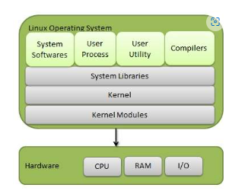**System Utility** − System Utility programs are responsible to do specialized, individual level tasks.

## **Basic Features**

Following is some of the important features of Linux Operating System.

* **Portable** − Portability means software can works on different types of hardware in same way. Linux kernel and application programs supports their installation on any kind of hardware platform.
* **Open Source** − Linux source code is freely available and it is community-based development project. Multiple teams work in collaboration to enhance the capability of Linux operating system and it is continuously evolving.
* **Multi-User** − Linux is a multiuser system means multiple users can access system resources like memory/ ram/ application programs at same time.
* **Multiprogramming** − Linux is a multiprogramming system means multiple applications can run at same time.
* **Hierarchical File System** − Linux provides a standard file structure in which system files/ user files are arranged.
* **Shell** − Linux provides a special interpreter program which can be used to execute commands of the operating system. It can be used to do various types of operations, call application programs. etc.
* **Security** − Linux provides user security using authentication features like password protection/ controlled access to specific files/ encryption of data.

## **Architecture**

The following illustration shows the architecture of a Linux system –

**1. Kernel: -** The kernel is one of the core sections of an operating system. It is responsible for each of the major actions of the Linux OS. This operating system contains distinct types of modules and cooperates with underlying hardware directly. The kernel facilitates required abstraction for hiding details of low-level hardware or application programs to the system. There are some of the important kernel types which are mentioned below:

* Monolithic Kernel
* Micro kernels
* Exo kernels
* Hybrid kernels

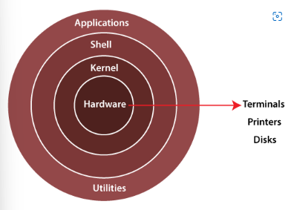

**2. System Libraries: -** These libraries can be specified as some special functions. These are applied for implementing the operating system's functionality and don't need code access rights of the modules of kernel.

**3. System Utility Programs: -** It is responsible for doing specialized level and individual activities.

**4. Hardware layer:-** Linux operating system contains a hardware layer that consists of several peripheral devices like [CPU](https://www.javatpoint.com/central-processing-unit), [HDD](https://www.javatpoint.com/hdd), and [RAM](https://www.javatpoint.com/ram).

**5. Shell: -** It is an interface among the kernel and user. It can afford the services of kernel. It can take commands through the user and runs the functions of the kernel. The shell is available in distinct types of OSes. These operating systems are categorized into two different types, which are the **graphical shells** and **command-line shells**.

The graphical line shells facilitate the graphical user interface, while the command line shells facilitate the command line interface. Thus, both of these shells implement operations. However, the graphical user interface shells work slower as compared to the command-line interface shells.

There are a few types of these shells which are categorized as follows:

* Korn shell
* Bourne shell
* C shell
* POSIX shell

## **Linux Distributions List**

There are on an average six hundred Linux distributors providing different features. Here, we'll discuss about some of the popular Linux distros today.

## **1) Ubuntu**

It came into existence in 2004 by Canonical and quickly became popular. Canonical wants Ubuntu to be used as easy graphical Linux desktop without the use of command line. It is the most well-known Linux distribution. Ubuntu is a next version of Debian and easy to use for newbies. It comes with a lot of pre-installed apps and easy to use repositories libraries.

Earlier, Ubuntu uses GNOME2 desktop environment but now it has developed its own unity desktop environment. It releases every six months and currently working to expand to run on tablets and smartphones.

## **2) Linux Mint**

Mint is based on Ubuntu and uses its repository software so some packages are common in both.

Earlier it was an alternative of Ubuntu because media codecs and proprietary software are included in mint but was absent in Ubuntu. But now it has its own popularity and it uses cinnamon and mate desktop instead of Ubuntu's unity desktop environment.

## **3) Debian**

Debian has its existence since 1993 and releases its versions much slowly then Ubuntu and mint.

This makes it one of the most stable Linux distributors.

Ubuntu is based on Debian and was founded to improve the core bits of Debian more quickly and make it more user friendly. Every release name of Debian is based on the name of the movie Toy Story.

## **4) Red Hat Enterprise / CentOS**

Red hat is a commercial Linux distributor. These products are red hat enterprise Linux (RHEL) and Fedora which are freely available. RHEL is well tested before release and supported till seven years after the release, whereas, fedora provides faster update and without any support.

Red hat uses trademark law to prevent their software from being redistributed. CentOS is a community project that uses red hat enterprise Linux code but removes all its trademark and make it freely available. In other words, it is a free version of RHEL and provide a stable platform for a long time.

## **5) Fedora**

It is a project that mainly focuses on free software and provides latest version of software. It doesn't make its own desktop environment but used 'upstream' software. By default, it has GNOME3 desktop environment. It is less stable but provides the latest stuff